8.13

Weekly strategy pnl breakdown

Pnl analysis

Parameter tuning

1. Increase percentileMATrader size (to 4). Increased PMCHY delta to 3mm for percentileMAtrader to keep accumulating size when pm drops.
2. Hilo trading. Use size 1 first.
3. Hilo – put in percentile constraint . (currently as of 8/13, condition is pmchy < 0 || percentile < 20.
4. First Tick trader– completely wrong on TUE -> cut its size. Needs to depend on percentile and pmchg, size to 1. Also, ftick was wrong on THU, using the last value instead of a computed value, keep track of open and ftick in orders.
5. TUE: missed trading on TUE for INTRADAYMA
6. Intraday MA sell and intradayFirstTick lost money -> reduce size, increase order wait time to 2 times usual, put in percentile and pmchy constraint
7. Make sure there is no trading during lunch (11:30 to 1pm)
8. Fut open buy made money when percentile is right. ( made money on 7th and 8th), record 2day percentile on futopen
9. Keep futopen timing at 1 min, but set percentile constraint, avoid last thurs selling at low percentile
10. Intraday profit taker – don't understand much about this, keep size to minimal

8.14

On ytd’s trading

1. percentileMATrader worked well, bought in the morning and sold overnight
2. hilo in the pm was too late
3. cancelling orders has problems. Correct and specify more details on order status.

wtd analysis:

Monday was big down AM and big up PM.

Tues: four Ftick trades were did but there were no pm short.

8.15

1. couldn't get futOpen done
2. couldn’t get firstTick done
3. consider using IOC/FOK
4. or when there is currently no orders, the first order should be an aggressive order

why was there no MA buys today?

percentile MA: constrained by delta, it is limited by up and down delta limits, drift delta towards target delta

intradayMA: constrained by pmchy, each day only 1 direction possible.

FirstTickTakeProfit: there was 0 first tick trade, it wasn’t filled. Think about how to force a fill on this one, maybe try aggressive.

After market:

1. first tick gotta be more aggressive

8.16

1. fut open first order didn't work. It was cancelled due to IOC. Next time check bid/ask to see if price didn't reach tradable price. Can trade @ bid/ask directly.
2. First tick didn't trigger, that was good. If first tick was up, it would trigger.
3. china hilo worked. But it worked depending on the first tick. What if the first tick was up? (firstTickTrader would buy and hilo would do nothing)
4. Check cancel trades on futOpen – pendingCancel status wasn’t included in the list. (resolved)
5. China HiLo on restart had problem – bought at the top. Need to recompute direction upon restart. (resolved)
6. China hilo – how to determine size? (Keep current size so far)

8.17

Weekly review:

Stocks: Single worst week. Blue chips get sold off very heavily.

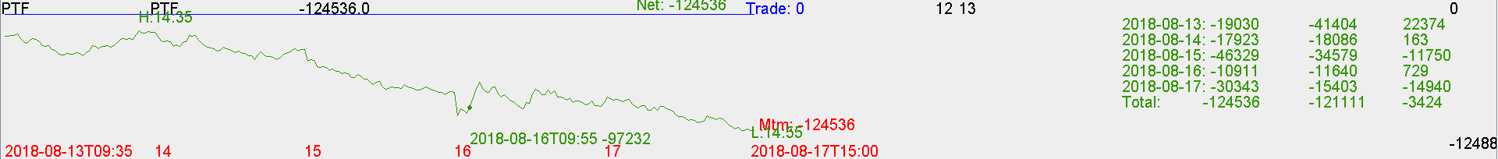

Futures:

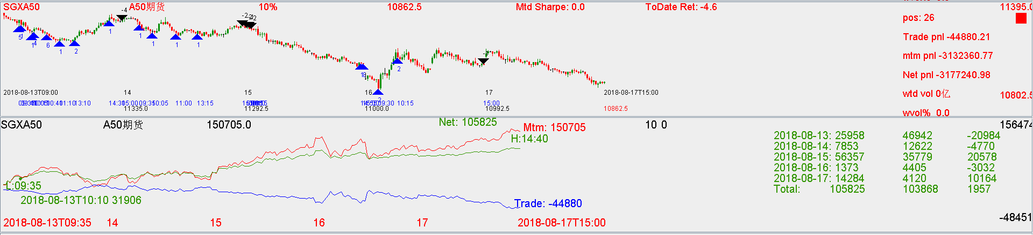

**Future trading:**

Tue: there was 4 ftick take profit trades without a ftick trade.

Wed: first tick and futOpen didn't get executed (they have to be executed)

Thur: first hilo: china hilo can have higher size.

Fri: given ytd’s close, can short aggressively. Add Ytd’s close

Tomorrow: put in end of day percentile as one of the parameters.